DESIGN AND ANALYSIS OF ALGORITHM-CSA0619
CO2: ASSESMENT TOOL 3
Qn. 1: Source code
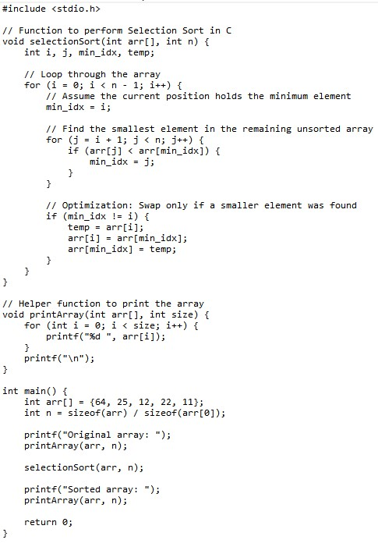
Output:
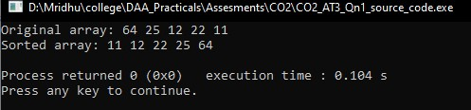

Analysis:
Complexity Case | Time Complexity | Explanation
Best Case | $$O\left(n^{2}\right)$$ | The outer loop runs $n$ times, and the inner loop always compares remaining elements regardless of whether the array is already sorted.
Average Case | $$O\left(n^{2}\right)$$ | Total comparisons across all passes equal $\frac{n\left(n-1\right)}{2}$.
Worst Case | $$O\left(n^{2}\right)$$ | Occurs when elements are completely reversed; requires the maximum number of comparisons and swaps.
Space Complexity | $$O\left(1\right)$$ | Performs swaps in-place using a constant amount of extra memory.
Justification of Time Complexity
For an array of length $n$:
- Pass 1 ($i=0$): Inner loop compares $n-1$ elements.
- Pass 2 ($i=1$): Inner loop compares $n-2$ elements.
- Pass $k$: Inner loop compares $n-k$ elements.
Summing total comparisons across all passes:
$$\text{Total Comparisons}=\left(n-1\right)+\left(n-2\right)+…+1=\frac{n\left(n-1\right)}{2}=\frac{n^{2}-n}{2}$$
Dropping lower-order terms and constant factors yields a time complexity of $O\left(n^{2}\right)$.

